Open your program so that you can run/play the program.

- Go to www.Screencast-o-matic.com
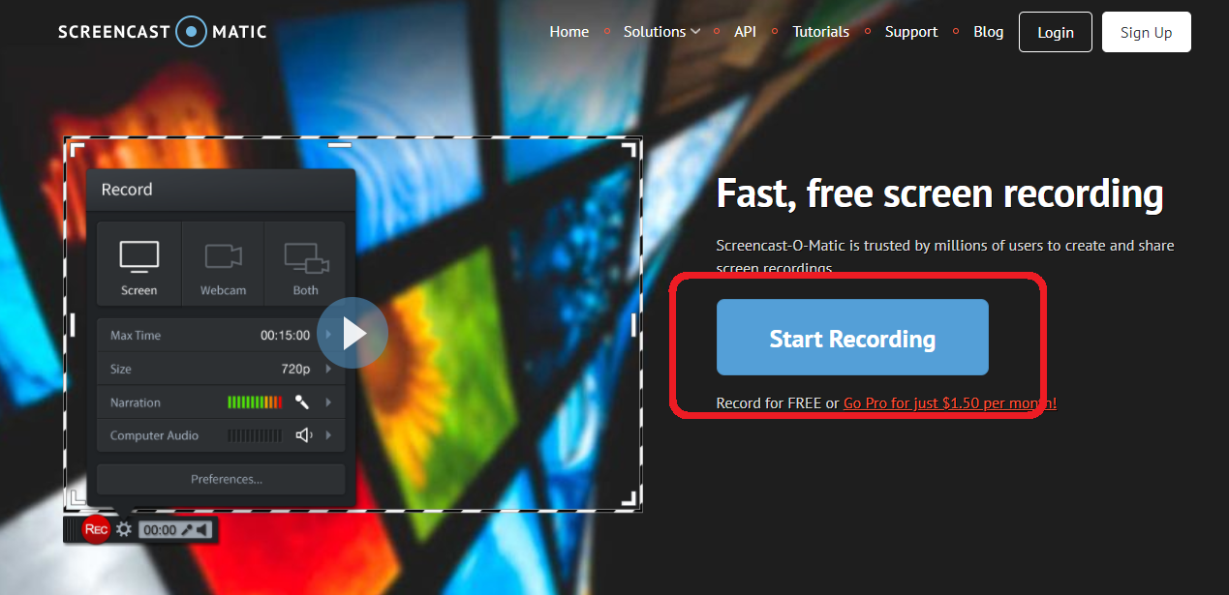
- Click START RECORDING on the next page it will have a green LAUNCH RECORDER button
- An .exe program will start
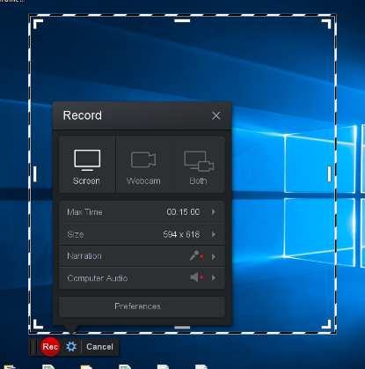

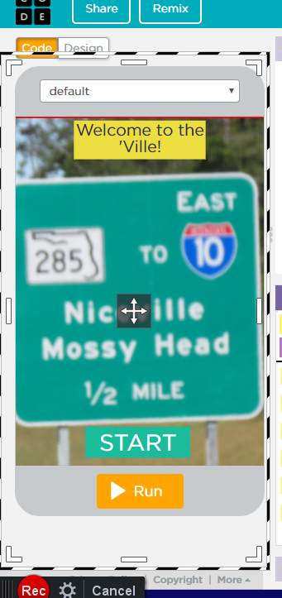

- Go to your project and make sure the dotted lines are around the part of the screen that will show your project as it is being used.

- Click REC and Run your program in 45 seconds or less

- Click the pause. Check your time. Click DONE

- Screencast-o-matic will allow you to preview your work. Watch it to see if there is something you may have left out of the video. If you like your results, SAVE AS FILE VIDEO. (type MP4, FILENAME should have no spaces and should not have your name in it – initials are okay. Save it to a folder you can find for when we need to upload it to Collegeboard

- It will take some time to save it. Once it’s completed, check to see that you can play the video from the file folder.

